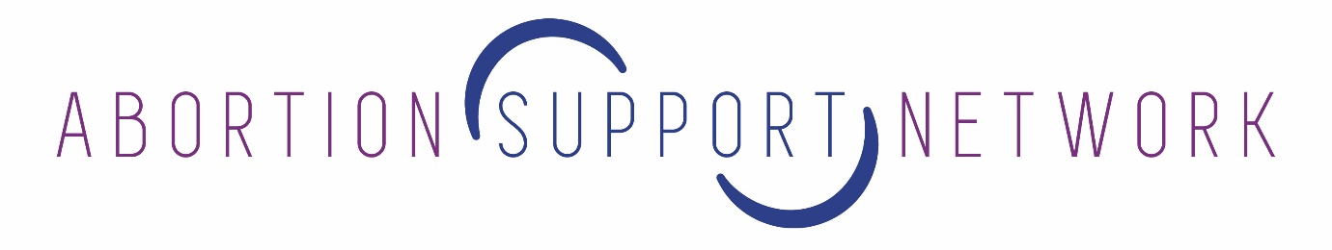
FROM: Mara Clarke
Founder, Abortion Support Network
Registered UK charity, serving Ireland, Northern Ireland and the Isle of Man, soon to be expanding to Malta, Gibralter and Poland.
E-mail: mara@asn.org.uk
Web: www.asn.org.uk

TO: command.papers@gibraltar.gov.gi

RESPONSE TO:
GIBRALTAR – A COMMAND PAPER FOR A DRAFT BILL TO AMEND THE CRIMES ACT 2011 TO PERMIT ABORTION IN CERTAIN LIMITED CASES AS REQUIRED BY THE JURISPRUDENCE OF THE SUPREME COURT OF THE UNITED KINGDOM

https://www.gibraltar.gov.gi/new/sites/default/files/press/2018/Press%20Releases/590-2018.pdf

Abortion Support Network is a grassroots charity that provides practical information on the least expensive way to arrange abortion and travel, information on safe but illegal early medical abortion pills from online sources and the post, financial assistance towards the cost of travelling to England and other countries to access legal abortion and, when needed, accommodation in volunteer homes. We currently provide this service for women and pregnant people resident in Ireland, Northern Ireland, the Isle of Man and the Channel Islands but will be expanding to Gibraltar and Malta in early 2019 unless there is law reform allowing safe, legal abortion for residents in those countries.

ASN is an abortion fund. This means we believe “I can’t afford an abortion” shouldn’t be the only reason someone becomes a parent.

We are not a campaigning organisation but a small charity that helps those needing abortions with money and other practical aspects and information. We do this work because we know that making abortion against the law doesn’t stop abortion. It just means that when faced with an unwanted or non viable pregnancy, those with money have the option to access safe care and those without money either have children they don’t want or can’t afford, or risk criminal prosecution by accessing safe but illegal pills from the internet, or who choose other more dangerous methods of trying to self-terminate. We say this, not as empty rhetoric, but because our experience has shown that this is fact. Here is a list of things people in Ireland, Northern Ireland and the Isle of Man have done before finding our contact details:

- Chased 3 packs birth control pills with a bottle of gin
- Sold kids’ Christmas presents
- Rationed food for the family
- Asked the rapist for a loan
- Not fixed broken brakes on the car
- Skipped paying rent
- Drunk floor cleaner
- Had a partner hit her repeatedly in the stomach
- Tried to figure out how to crash the car badly enough to cause a miscarriage but not die

“Please help. I've tried everything to try to miscarry...I've been drinking excessively, I've tried throwing myself downstairs, and even tried to overdose. I can't have this child. I don't want it!”

Grim, right? And this is why we very much welcome the initiative from Gibraltar to update its abortion law provide women and pregnant people with abortion services on Gibraltar, which will hopefully negate the current need to travel to England, Spain and other countries at enormous expense, or to consider breaking the law by taking safe but illegal abortion pills sourced online, or to take more dangerous methods to self-terminate their pregnancies. We all know that making abortion doesn’t stop abortion, but only stops abortion for those who do not have the £400 to £2000 it costs to travel to England to access care.

Abortion Support Network welcomes an update to the law in Gibraltar. We know groups like No More Shame, Gibraltar Pro Choice, bpas, the International Campaign for Women’s Right to Safe Abortion and others have made submissions, and our hope is the good people on the Isle of Man, who themselves recently voted unanimously to update their archaic law, have also made a submission. All of these groups, unlike us, are experts in abortion law, politics, and law reform. Groups like those are the cure to abortion laws that penalise women who are poor and women who are marginalised, women who are in or escaping abusive relationships. Abortion Support Network is simply the plaster on this situation, and, while we are mighty beyond our small size, we are also limited in our ability. We cannot help everyone, and our hope is that Gibraltar makes substantive legal reform before ASN is in a position where we are able to send you case studies of women who have been forced to contact us from Gibraltar for help.

Here are words from some of the people we’ve heard from since we switched on our phone in October 2009:

“My finances are very stretched with caring for my family. I live in rural Ireland and the travel alone is more than I can afford.”

"I have recently got out of a violent relationship and cannot have a baby that will tie me to this man forever. I am struggling to get the money up and am wondering if yous can help me with money please.”

“I cannot afford nor provide for a child yet I cannot afford an abortion. I feel sick thinking about it. I feel like I have no choices due to lack of money.”

“I was raped last month but never did anything about it as I blamed myself. I need to have an abortion but I haven’t got the money.”

“My teenage daughter is pregnant and the stress of it has made her suicidal.”

"I hate the thought of abortion but my baby's not going to make it. I can't stand the thought of watching my baby die".

“I was completely against abortion until my partner and I both lost our jobs. There is no way we can get ourselves back on our feet if we have another child right now.”

While we won’t go through the Gibraltar command paper point by point, we can tell you, definitively, that any restriction on abortion in your country will only impact those who are most vulnerable and at risk. This includes any hurdles put in the way of accessing care, such as requiring more than one visit to medical professionals, any cost of service, any requirement to “prove” need for an abortion. Those with financial resources will be able to gather funds, arrange childcare, book flights and travel to other jurisdictions with less restrictive laws. Those without funds, those who are in or escaping abusive relationships, those who don’t have support networks to help with cost and childcare – those are the ones who will (continue to) suffer.

Thank you for your consideration.

